Navigating Course Login App

This guide explains how to use the app for logging employees into courses, retrieving course or employee history, and adding/editing employees or courses.

Logging In

The app is available here: <https://maintenance-training-records.streamlit.app/>

If the app has been idle for too long, it’ll shut down and you’ll see this screen:  
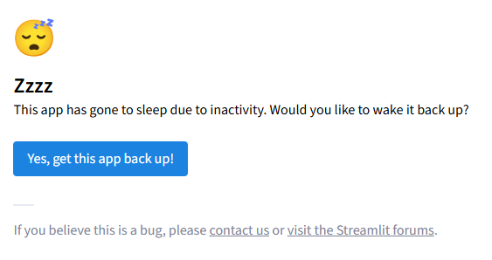

This is not a bug, just select “Yes, get this app back up!” and it’ll start the app.

Navigating the pages

Once you’re signed in, you’ll see the option to Sign Employees Into Course on the Course Sign In page.

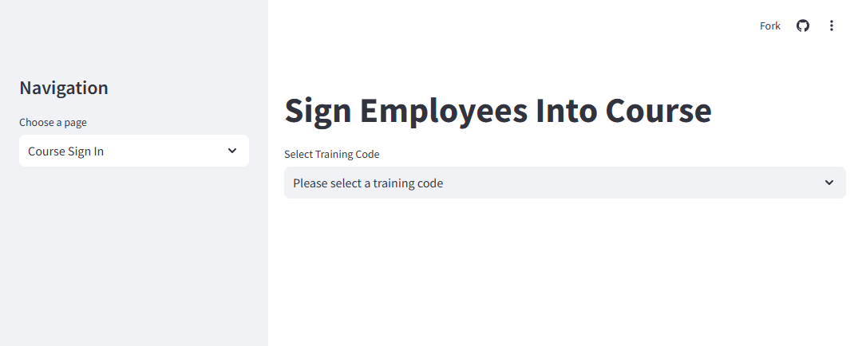

On the left is there Navigation drop down that’ll let you visit the other pages:

* Course Sign In
* Activity History
* Employee Management
* Course Management

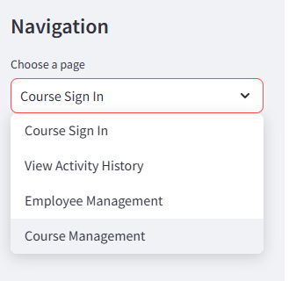

I’ll go through each page’s functionality.

Course Sign In:

First step is selecting a Training Code:

* OSHA
* Technical

Based on your selection, only those corresponding courses will be in the dropdown in Select Course.  
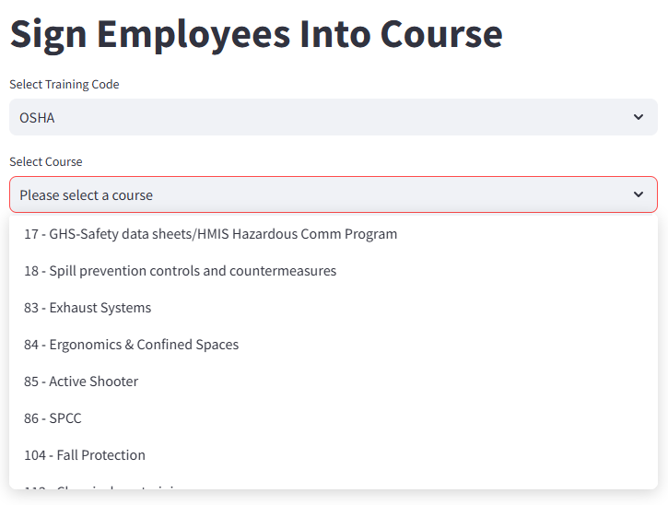

When a course is selected, the user will then have the option to Select Employees where they can select multiple employees to sign into a class. The employees displayed in this dropdown will always be active so there is no chance a terminated employee can be signed into a course.

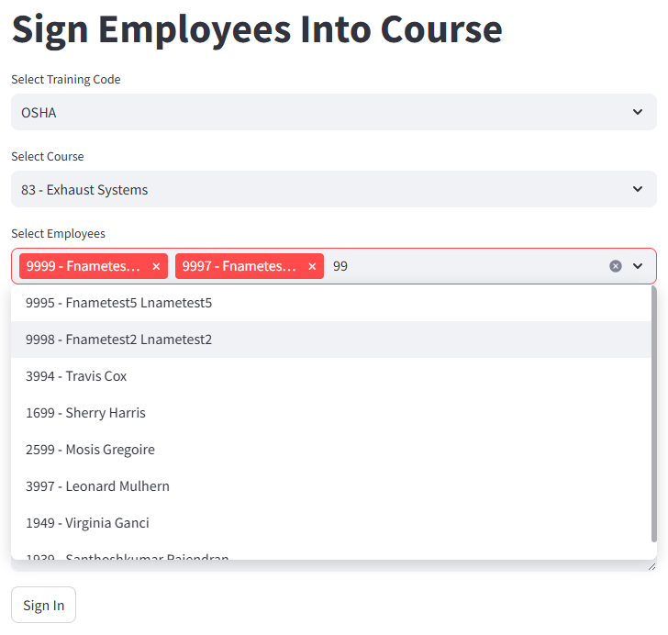

The Date will always default to the current date however this is editable in case employees were missed.

Hours increase in increments of .5 however a user can also type any numerical value, such as .33 or .75. Whatever value is in Hours will be applied to reach student’s record in regards to the course.

And lastly there is an option to add comments before selecting Sign In to enter the users into the course.  
When you select Sign In, you’ll see an “Employees signed into course!” success message:  
  
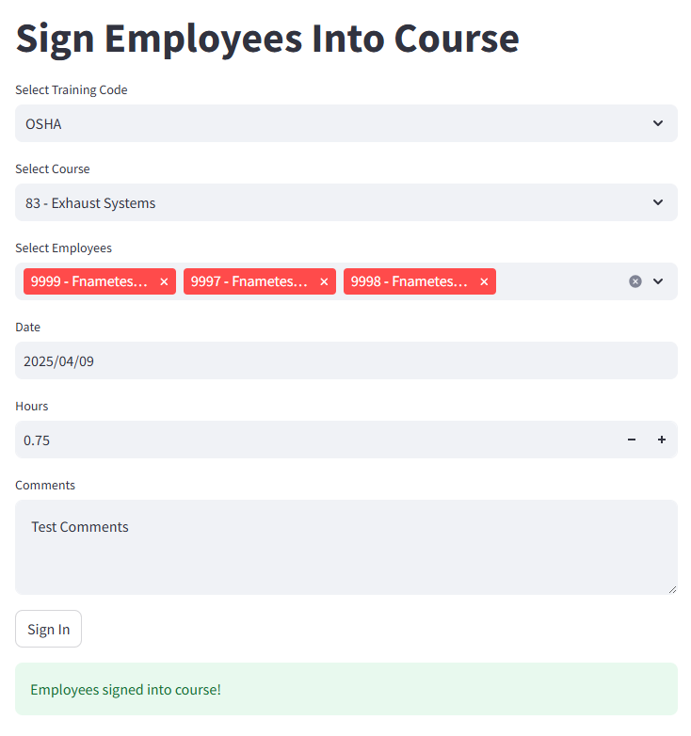

View Activity History

The second page of the app is Activity History where you can pull up complete historical records of either employees or courses.

When you open up Activity History, you’ll be on Employee Course History by default but there is always a tab for Course Attendance for when you want to look up course history.

To view the complete history from an employee, just select an employee from the Select Employee dropdown and a table with their courses, dates, and hours will appear.

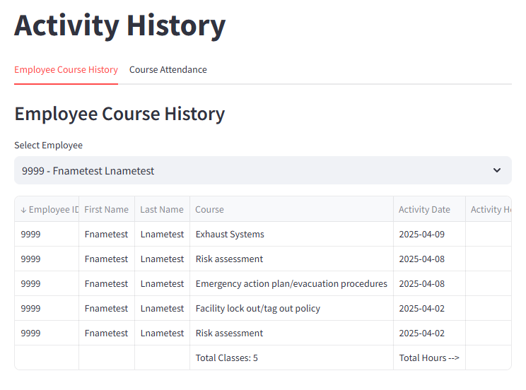

This table is scrollable so you can go to the right to see more information. When a user hovers over the top right corner of the table, options appear to hide/view columns, download as a CSV, search, and expand.

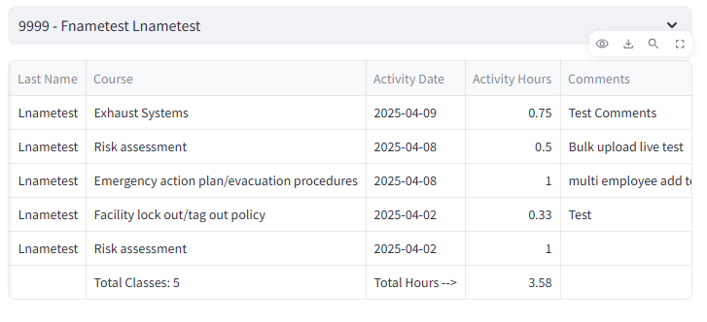

Selecting the Course Attendance tab will prompt the user to select a Training Code. Once either OSHA or Technical is selected, only those corresponding courses will be in the Select Course dropdown along with an All option.

The All option will return all of the course attendance data for the training code with a total hours and attendees at the bottom of the table.

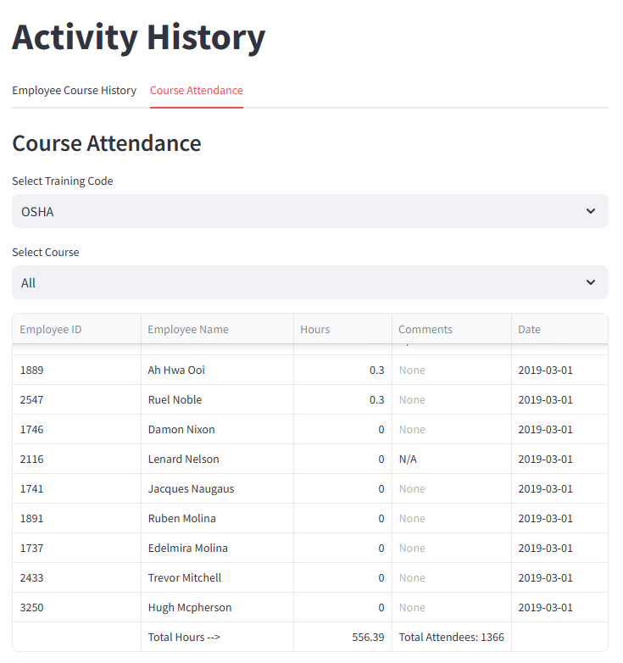

Employee Management

This page will allow users to review employees’ data like ID, Hire Date, Termination Date, and Status, enter new employees, and edit existing Employee.

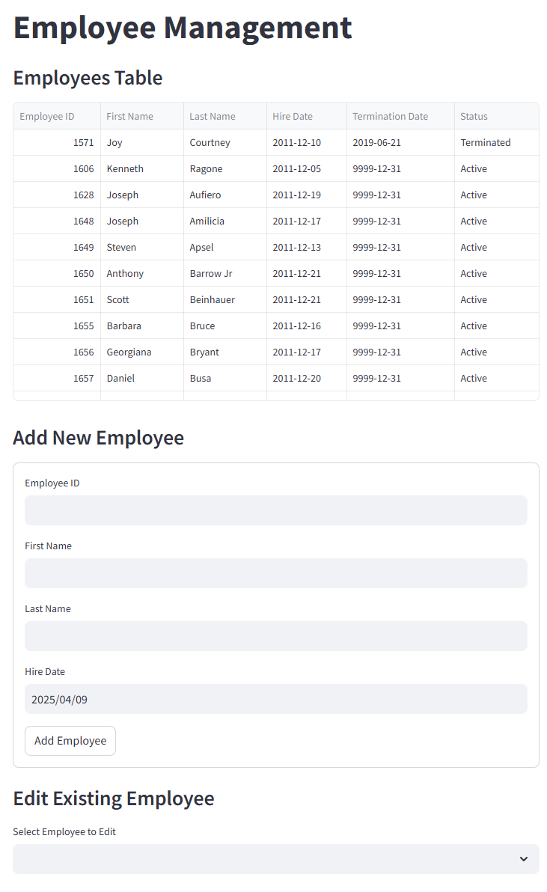

The Employees Table works like all of the other tables within the app where there is the option to hide/view columns, download as a CSV, search, or expand the table when the user hovers over the top right corner of the table.

Below the Employees Table is the Add New Employee section. All the user needs to do is add the corresponding data and select Add Employee. Of note, the new employee will always be added to the bottom of the Employees Table and will automatically have a Termination Date of 9999-12-31, and Status of Active.

Lastly is Edit Existing Employee. A user here can select an employee and edit their First Name, Last Name and Status. Should the status of an employee need to update to Terminated, a Termination Date option will appear that defaults to the current date however is editable before selecting the Update Employee button.

Course Management

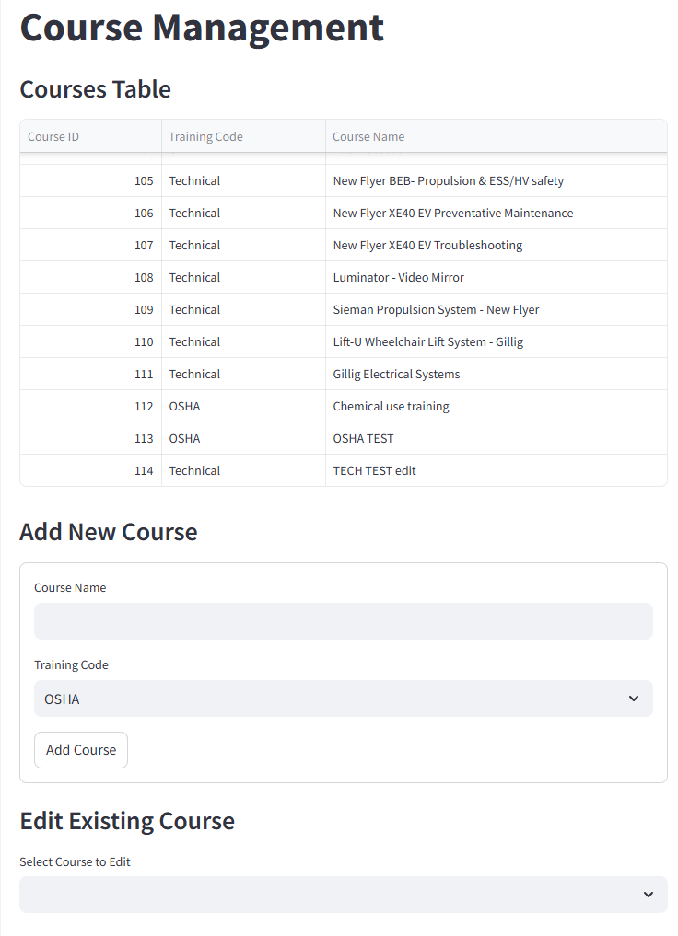

The Course Management page is very similar to the Employee Management page in both look and functionality.

On this page, users can view all courses in the Course Table, add new courses, and edit existing courses.

When a course is added, the user will name the course, and then determine whether the course is an OSHA or Technical course. When they select the Add Course button, this will add the course to the Courses Table at the bottom and automatically generate a sequential Course ID.

Users can also edit existing courses names or training codes and those updates to automatically be applied and added to the Courses Table.

